Speaker Bios, MRASH 2017

R. L. "Dick" Wittman

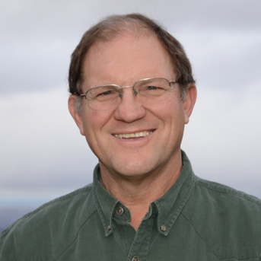
Dick Wittman is former manager and board chair of a 20,000-acre crop, cattle and timber operation in Idaho and also provides consulting services on a part-time basis to agri-businesses and farmer/ranchers. After receiving degrees in Ag Economics from the University of Idaho and an MBA from the University of Utah, Wittman worked for the Farm Credit System from 1972-1980 concluding his lending career with the Farm Credit Administration in Washington, D. C., where he supervised Farm Credit operations covering 17 states in the East, mid-West, and Southern U. S.
Wittman has consulted throughout the U. S., Canada, and Australia on financial management, process improvement, developing management systems and solutions for business relationship/transition problems. In January, 2004, he released a 271 page guidebook entitled Building Effective Farm Management Systems. The guidebook provides a toolkit for commercial-size family farm business to define their ultimate vision and put in place a professional management and transition process that will lead to that goal.
Wittman is a founding member, director and past president of the Pacific Northwest Direct Seed Association, has been an active leader and director on several industry, community and financial institution boards, and is an adjunct faculty member of Texas A&M University teaching annually at the TEPAP Ag Executive Program in Austin, Texas since 2003 and the King Ranch Institute. He is a past president and member of the board of the Farm Financial Standards Council and also serves on a national advisory board for Environmental Defense Fund providing policy development leadership in sustainability initiatives and climate change legislation impacting agriculture. He has served on the Farm Journal’s Legacy Institute Board of Advisors focusing on succession planning since 2013.

Michele Devlin, DR.P.H.

Dr. Michele Devlin is Professor of Global Public Health, Chair of the Division of Health Promotion and Education, and Co-Director of the BAS in Tactical Emergency Services with Vulnerable Populations program at the University of Northern Iowa. She is also founder of the Iowa Center on Health Disparities there, a model organization established by the National Institutes of Health to improve health equity for underserved populations, and Director of the UNI Global Health Corps humanitarian relief organization. Dr. Devlin is also Adjunct Research Professor with the United States Army War College in Carlisle, Pennsylvania. She completed her doctorate degree in international public health at the University of California at Los Angeles. Her primary areas of specialty include human migration and cross-cultural emergency and disaster response with refugee and minority populations. She has published nearly 100 articles, reports, and books including “Health Matters: A Guide to Working with Diverse and Underserved Populations”; “Postville USA: Surviving Diversity in Small-Town America”; and the forthcoming “Tactical Anthropology: A Practical Guide for Emergency Responders in Culturally Diverse Communities.” In addition to her academic expertise, Dr. Devlin has more than 25 years of field experience working with public safety, law enforcement, public health agencies, non-profits, and disaster relief organizations around the world in culturally complex communities. Dr. Devlin is the Cultural Awareness Trainer for the Iowa Department of Public Safety and the Iowa Law Enforcement Academies, and a staff trainer for the International Law Enforcement Educators and Trainers Association. She is an international disaster relief team member with the American Red Cross, and has served in Haiti and the Philippines. She has led and/or participated in multiple medical missions around the world in Latin America, Africa, Asia, and the Middle East. Dr. Devlin is a licensed Emergency Medical Responder, and member of the Star One Search and Rescue Team in Iowa; the Iowa Disaster Medical Assistance Team; Disaster Mortuary Operational Team; multiple FEMA Community Emergency Response Teams; and the Medical Reserve Corps. She has provided training and technical assistance on cultural terrain issues to thousands of law enforcement, public safety, search and rescue, disaster response, public health, and emergency management professionals at the federal, state, and local level. Dr. Devlin is the recipient of the One Iowa Award, the Iowa Women’s Hall of Fame Award, the Iowa Civil Rights Award, and other local, state, and national honors for outstanding teaching, scholarship, and service. She has extensive travel experience in over 50 nations around the world, and also served with the U.S. Army Corps of Civilians in Afghanistan during Operation Enduring Freedom as a lead social scientist.

Mark A. Grey, PH.D.

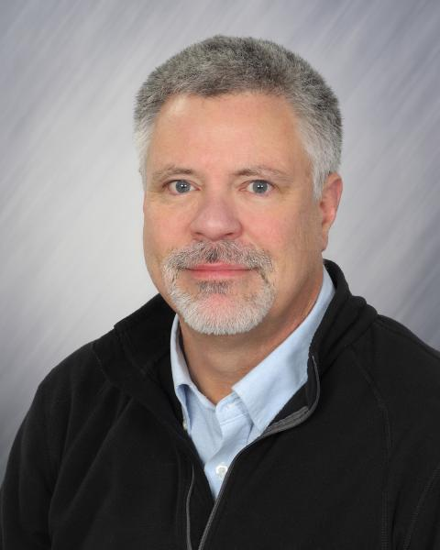
Mark A. Grey, Ph.D. is Professor of Applied Anthropology at the University of Northern Iowa (UNI), and Chair of the new BAS program in Tactical Emergency Services with Vulnerable Populations. He is also Adjunct Research Professor with the United States Army War College in Carlisle, Pennsylvania, and a specialist in mass human migration and emergency response. Dr. Grey is founder of the UNI New Iowan’s Center, an award-winning program that provides technical assistance and training to law enforcement agencies, intelligence units, emergency managers and emergency medical personnel dealing with the unique challenges associated with influxes of immigrant and refugee newcomers. Dr. Grey received his Ph.D. in Applied Anthropology at the University of Colorado-Boulder. He has published extensively in academic and non-academic journals with recent articles in Iowa Law Enforcement Magazine. His books include the forthcoming Tactical Anthropology; as well as Postville USA: Surviving Diversity in Small-Town America and Health Matters: A Pocket Guide for Working with Diverse Cultures and Underserved Populations. Dr. Grey has won numerous awards for his activities, including the 2013 Friend of Iowa Civil Rights, the Iowan Immigrant Champion Award, One Iowa Award, Iowa Friends of Civil Rights Award, Iowa Council for International Understanding Vision Award, and the Iowa Regents Award for Faculty Excellence. Dr. Grey is an Iowa-licensed Emergency Medical Responder and a nationally certified Search and Rescue Technician. He volunteers for numerous state and local organizations including the American Red Cross, Star One Search and Rescue Team, several FEMA Community Emergency Response Teams (CERT), the Iowa Mortuary Operational Response Team (I-MORT) and the Iowa Attorney General’s Human Trafficking Task Force. Dr. Grey serves as a consultant and trainer for the Iowa Departments of Public Safety, Public Health, and Human Services. He is also an instructor for the Iowa Law Enforcement Academy and the Iowa Department of Public Safety Basic Academy.

