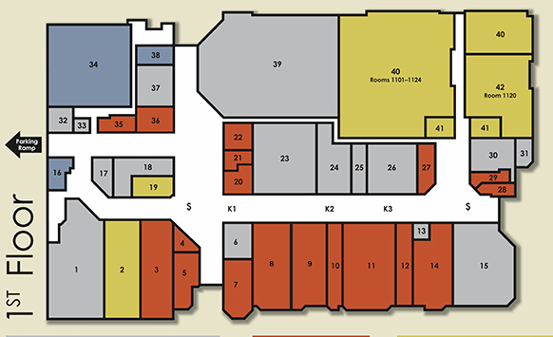
Walking path on the first level is around 527 steps and the second level is around 573 steps. 2000 steps is an estimated mile.
