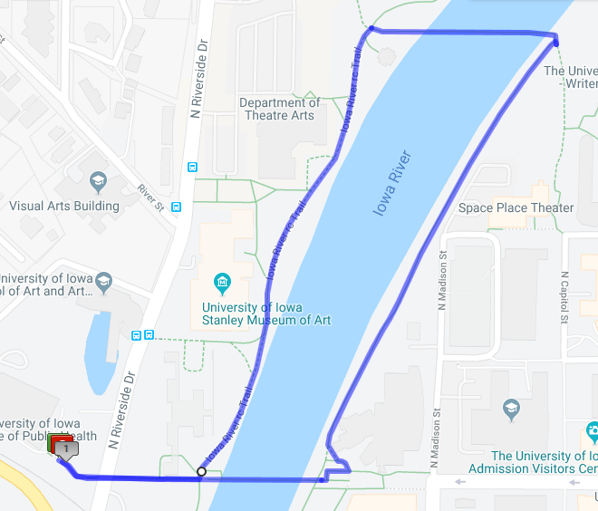
1 mile- stairs

College of Public Health, down east stairs, walk either side of the river north and crossing the two footbridges
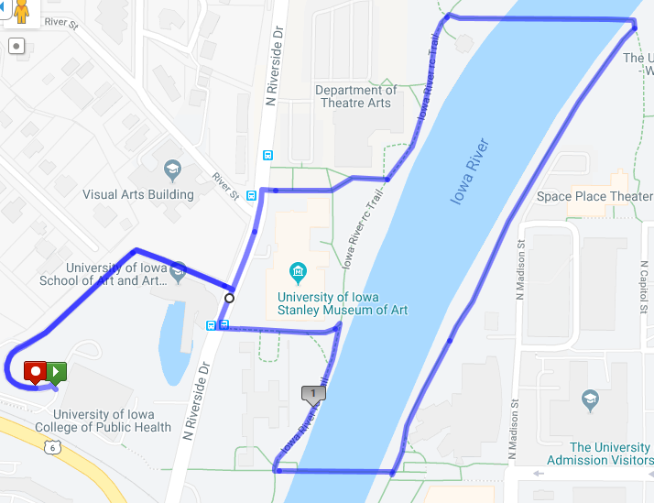
1.35 mile - no stairs
College of Public Health, down sidewalk along the driveway/entrance, cross N. Riverside Dr, north along river, cross Hancher footbridge, walk south along river, cross IMU footbridge, north along river to Museum, returning along driveway/entrance
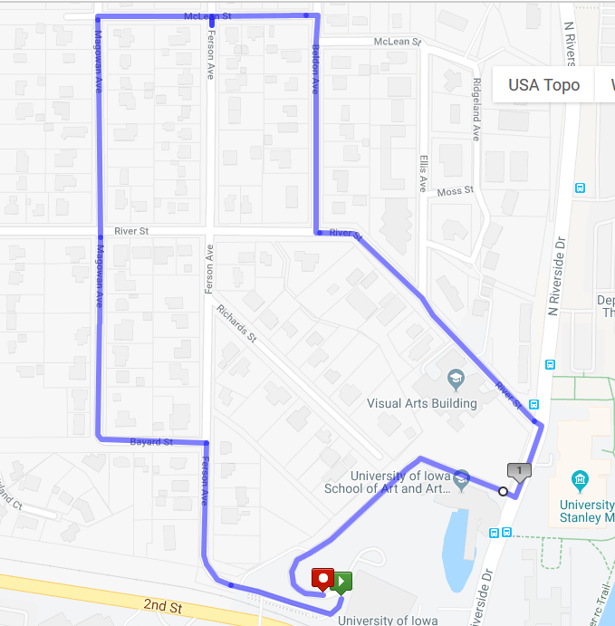
1.2 miles – no stairs
College of Public Health, Ferson Ave, Bayard St, Magowan Ave, McLean St, Beldon Ave, River St, walk along School of Art, to the driveway/entrance

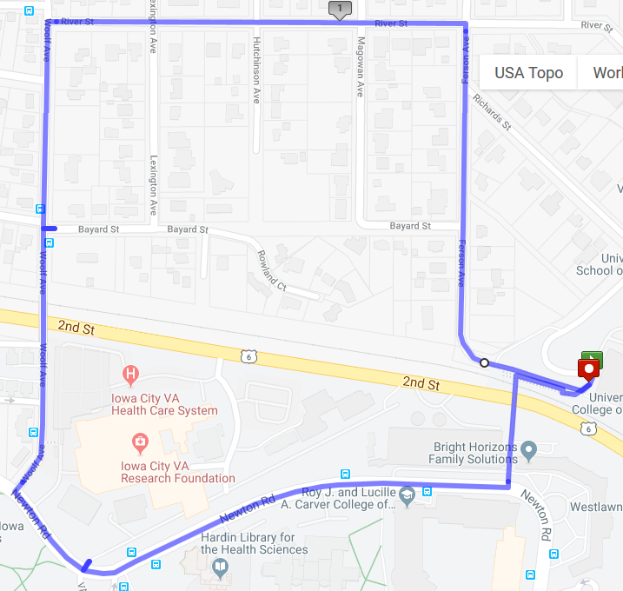

1.37 miles – no stairs
College of Public Health, cross footbridge, Newton Rd, Woolf Ave, River St, Ferson Ave

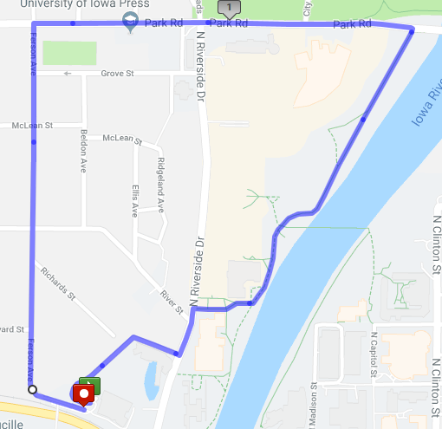

1.79 miles – no stairs
College of Public Health, Ferson Ave, Park Rd, south along river

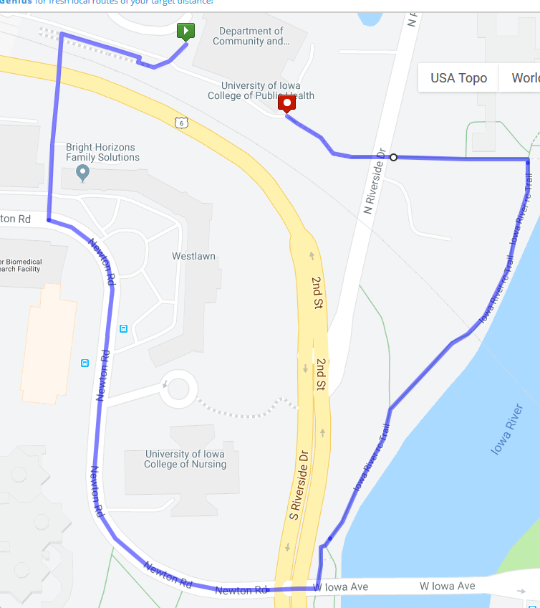

.64 miles- stairs
College of Public Health, cross footbridge, Newton Rd, ramp over Riverside Dr and under Iowa Ave, north along river, return up east stairs

