HOW DO I PLAY MORE AT WORK AND HOME HANDOUT
Step 1: Sort your daily activities into two “buckets” WORK and PLAY (work and play is how you think about the task and not where the task occurs, meaning a work task may be something you do at home, etc.)
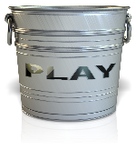
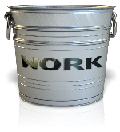
___________________________________ __________________________________
___________________________________ ___________________________________
___________________________________ ___________________________________
___________________________________ ___________________________________
___________________________________ ___________________________________
___________________________________ ___________________________________
___________________________________ ___________________________________
___________________________________ ___________________________________
___________________________________ ___________________________________
STEP 2: Find YOUR play equation
Choose a few activities that you LOVE and come up with words for each category that cause you to love that activity. Circle or highlight the common themes you see within your chart.
ACTIVITY  (Play) | ACTIONS | EXPERIENCE | RESULT

HOW DO I PLAY MORE AT WORK AND HOME HANDOUT
Step 3: Pick a few of your WORK items and complete the chart.
TASKS | DISLIKE | FIXES (INSERT PLAY) | RESULTS

