Field Experience Narrative Report – State Hygienic Laboratory COVID-19 Surge Capacity Support
Dates: January 14, 2021 – February 24, 2022

Host Site:
Cynthia Cass, PhD, Assistant Director of DCD Operations, Operations Manager COVID Response, State Hygienic Laboratory

Location:
The State Hygienic Laboratory at The University of Iowa (SHL) is Iowa’s public health and environmental laboratory. The Laboratory serves all of Iowa’s 99 counties through disease detection, environmental monitoring, and newborn and maternal screening. The main facilities are headquartered on the University of Iowa’s Research Park campus in Coralville, Iowa.

Need from Host site:
As the cases of COVID in Iowa significantly increase so does the volume of samples for testing received by the State Hygienic Laboratory increase. Due to the unprecedented volume of samples received and need for testing collection kits to be constructed and sent, the SHL reached out to request surge capacity support from the UI CPH Strike Force

Learning Objectives & Gaps Filled:
Through this field experience, students will be able to:
- describe the importance of the public health laboratory in testing and reporting disease results during a pandemic surge event;
- compare and contrast the strategies used to provide public health test collection and analysis during a pandemic surge event versus a non-emergent event;
- explain the contribution and operations of a state public health and environmental laboratory, and
- describe the interface and communication required between the state laboratory, clinical laboratories, local public health departments, the state health department and the public to optimally track and mitigate a large-scale infectious disease outbreak.
- explain the importance of environmental testing through hands-on experience working and performing tests in a state environmental laboratory environment.

The gaps filled by this trip:
- Introduces students to the importance of planning for and implementing activities to address surge capacity issues,
- Provides hands-on experience in a state public health and environmental laboratory,
- Demonstrates the importance of the state public health laboratory in the identification, tracking and mitigation of a pandemic event, and
- Identifies the need to have multiple surge strategies to respond to large scale events.

Students Attending: (# of undergraduate & # of graduate students and field of study)
48 College of Public Health students responded to the request for volunteers. Of these, SHL contacted 9 students to be scheduled to assist with sample/test management. A complete analysis of the volunteers, their degrees, academic years and demographics is attached (Attachment 1)

Description of project:
On January 14, 2022, the Strike Force Faculty Sponsor was contacted by the SHL Acting COVID Incident Commander asking if the Strike Force could be deployed to provide surge capacity resources due to a significant increase in test kit requests and COVID test samples being received by the laboratory. Initiatives were immediately started to be able to effectively provide this support to the SHL. These initiatives included establishing dates and times surge capacity staff was needed, creating an online request and application from for the students, assuring that each student completed a UI volunteer authorization/waiver, developing a tracking system of volunteers to routinely share with SHL IC Operations and coordinating JIT training and security authorization for the students with Dr. Cass and her staff. This was all accomplished within one week after the initial request for Strike Force assistance.

Assignments for Strike Force members included working in:
- Central Accessioning
  - Receive, open and accession COVID test samples
  - Distribute sample collection kits to the public
- Test Iowa Laboratory
  - Pull samples for retesting
  - Discard racks of specimens already tested
  - Work on the non-activated sample list
  - Help processing of saliva samples and help in Prefills
- Central Services and Supply Management
  - Assist construction of sample collection kits

Description of Field Experience: (student perception & field staff perception)
The application survey included a question of why the student was interested in this opportunity. The word cloud has been created from these responses.
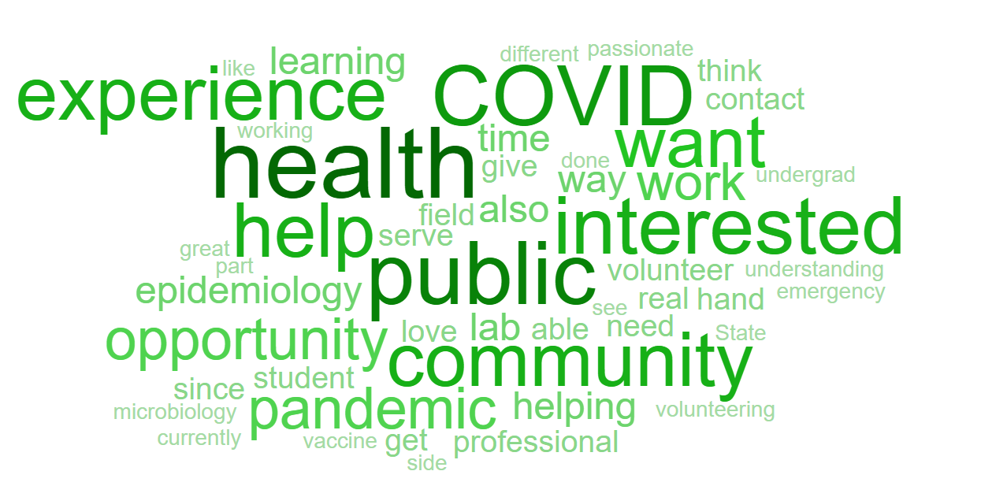
After Action Review with Dr. Cynthia Cass
B. Rubin met with Dr. Cass towards the end of the surge capacity need. Within two weeks of the initial request, the sample volume decreased by 67% thus reducing the need for surge capacity support. Areas of discussion included:
- Consideration of one electronic site that both parties can use to communicate student availability and schedule the shifts. Although done in a timely manner, daily availability spreadsheets sent to SHL was somewhat clumsy. Having the spreadsheets with version numbers helped greatly.
- Wondering if there are University systems that can be accessed for this type of event or the use of a volunteer site? Since this event, the Strike Force has implemented use of Sign-Up Genius for events.
- SHL tried to give as many students as possible the experience of working in the laboratory.
- Dr. Cass found the students to be very helpful and useful.
- SHL is working on creating trigger or tipping points that will anticipate the need for surge support.
- SHL realized they need more documentation for sample processing procedures, such as JIT training modules and consideration of always having a stable of students available to help.

